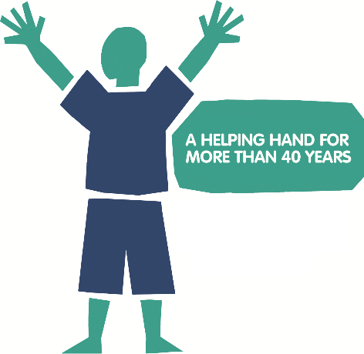
Thank you for your interest in
supporting the National Eczema Society in the london marathon 2023!
Before deciding to apply, please be sure you are confident in
meeting our minimum fundraising requirements of £1750.
As our places are limited, we ask applicants to fill in this form so we can get to know you. We’ll let you know our decision as soon as we can.
Please return your completed application to: fundraising@eczema.org
Our charity relies on donations. We are very grateful to you for supporting
us to continue our important work helping people living with eczema!
Name
Address
Postcode
Telephone
Email
Social media HANDLES
Terms and conditions
By completing this form, I confirm that if successful I agree to the following declaration:
- I commit to raising at least 50% of my £1,750 fundraising target 8 weeks before the event date and all monies are paid to the charity no later than 4 weeks after the event.
- I am aware that I am unable to defer my charity place in the London Marathon and would need to cancel my invitation.

EVENT | DATE | LOCATION | Fundraising Requirement
London Marathon 2023  Full Marathon | Sunday 23rd April | London | £1,750 | ☐

Why do you want to
run for the National Eczema Society charity?
Include information about your own personal connections to eczema
Have you participated in any running events before? | Yes ☐ | No ☐
Which events?
What was your finishing time(s)?
Do you have a target finishing time for this event?
Have you taken part in any other fundraising events? | Yes ☐ | No ☐
How much did you raise?
What is your fundraising target for this event?

Please provide an outline,
or some ideas for your own fundraising plan
We will provide a list of fundraising ideas to help you with this
Does your employer offer matched giving? | Yes ☐ | No ☐
We will send you a free running vest with our charity logo. Please indicate below requirements.
Preferred fabric | Cotton ☐ |  | Technical ☐
Required size | Small ☐ |  | Medium ☐ |  | Large ☐ | X-Large ☐

From the whole team at NES – thank you!

National Eczema Society
11 Murray Street
London NW1 9RE
T: 0207 281 3553
E: fundraising@eczema.org
W: www.eczema.org

