Open letter to the
Medicines and Healthcare products Regulatory Agency (MHRA)
Potency should be clearly labelled on topical steroids
to support safer and more effective use
National Eczema Society (NES) and the professional medical organisations listed below are asking the MHRA to address the lack of information about potency on topical corticosteroid products. Widespread anxiety about using topical steroids, amounting to steroid phobia, is well-documented and apparent from the many calls made to the NES eczema support helpline and from healthcare professionals’ clinical experience. Topical Steroid Withdrawal (TSW) reactions, recently highlighted by the MHRA, are widely discussed on social media with alarming photographs and testimony, apparently fuelling steroid phobia. For patients to use topical steroids safely and effectively, they need to understand their risks and benefits. Knowledge of potency is key because there can be up to a 600-fold difference in potency between different topical steroids¹.
NICE guidelines refer to four different potencies – mild, moderate, potent and very potent – corresponding to WHO Anatomical Therapeutic Chemical (ATC) code D07AA/B/C/D, where the fifth character, A-D, corresponds to potency I-IV. Every topical steroid preparation has a designated ATC code, which should be stated in the Summary of Product Characteristics (SPC) at section 5.1 Pharmacodynamic Properties. However, the code is rarely explained and potency information is very rarely present in the Patient Information Leaflet (PIL) and never on the packaging.
Resources are available for healthcare professionals to look up potency, but not for patients. Even if the prescriber has time to explain potency, we know that information given in clinic is imperfectly retained. The percentage concentration of the active ingredient is often incorrectly mistaken for potency, and the multiplicity of products at each potency level – with and without antimicrobials – adds to the confusion.
We acknowledge that there are potency differences between products within each of the four categories and different scales used in other countries. However, since every product licensed in the UK has a designated WHO potency code as stated in section 5.1 of the SPC, that code should be visible to patients in a simple, unambiguous, accessible way. Clearer potency labelling would help improve patient adherence, mitigate the risk of adverse effects, and enable a more balanced debate about topical steroids among patients and healthcare professionals.

We are calling for the MHRA to mandate pharmaceutical manufacturers to introduce clear potency labelling on topical steroid tubes, packaging and PILs. The labelling scheme must be standardised so that prescribers and patients become familiar with the way that potency is shown across all products. It must also be non-verbal to be independent of language and literacy level, as suggested in recent peer-reviewed articles ^{2,3}. The goal is to achieve a level of public understanding comparable to sunscreen strength using the Sun Factor Protection (SPF) labelling, which enables people to use sunscreens confidently and effectively.
Clearer potency labelling has strong support from healthcare professionals, as demonstrated by the number of organisations listed below endorsing this initiative. In a confidential survey, 91% of the 300 delegates attending the 2022 Annual UK Dermatology Course for Consultants explicitly supported the idea of clearer potency labelling for topical steroids. In an online patient survey in January 2023 conducted by NES, some 95% of 943 respondents said they would like to see clearer potency labelling for topical steroids and most (70%) said they would look for potency information on the tube or product packaging.
- Oakley A. Topical steroid. DermNet accessed 1 May 2023. https://dermnetnz.org/topics/topical-steroid
- Haider Z, Proctor P, Moss C. Potency of topical steroids should be clearly labelled on all packaging. Br J Dermatol. 2023 Feb 22;188(3):427-428. doi: 10.1093/bjd/ljac104.
- Wilson F, Harnik E, Gore C. A labelling system improves parental comfort and willingness to use topical corticosteroids for paediatric atopic dermatitis. Skin Health Dis 2021; 1:e11.

These organisations and their communities support the proposed introduction of clearer potency labelling for topical steroids:
British Association of Dermatologists
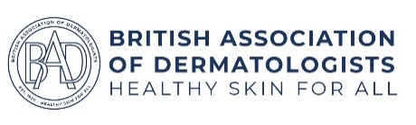
British Dermatological Nursing Group

British Society for Paediatric and Adolescent Dermatology
British Society for Allergy & Clinical Immunology
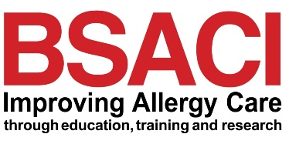
Eczema Outreach Support
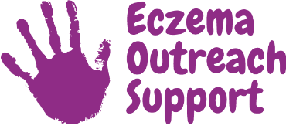
National Eczema Society
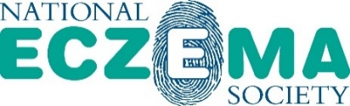
Primary Care Dermatology Society
Scottish Dermatological Society
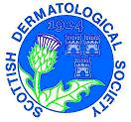

National Eczema Society is a registered charity in England and Wales (No. 1009671)
Registered Office: 11 Murray Street, London NW1 9RE
www.eczema.org | Email: info@eczema.org | Tel: 020-7283-3553

