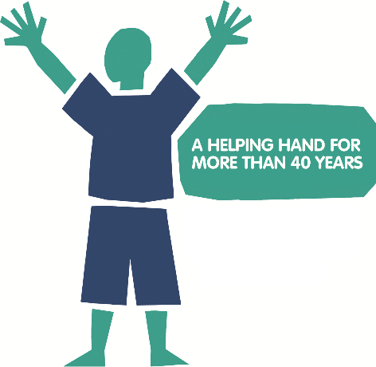
Thank you for your interest in
supporting the National Eczema Society!
We have a number of places available in some of the UK’s most prestigious running events in 2020.
Before deciding to apply, please be sure you are confident in
meeting our minimum fundraising requirements, as set out below.
As our places are limited, we ask applicants to fill in this form so we can get to know you. We’ll let you know our decision as soon as we can.
Please return your completed application to: fundraising@eczema.org
Our charity is funded entirely by donations. We are very grateful to you for supporting us to continue our important work helping people living with eczema!
Name
Address
Postcode
Telephone
Email
Social media HANDLES
Please select the running event you would like to be considered for, or if you need registration help please write in an event you’d like to participate in:
EVENT | DATE | LOCATION | Fundraising Requirement
London Marathon 2020  Full Marathon | Sunday 26 April 2020 | London | £2000 | ☐
Great North Run 2019  Half Marathon | Sunday 13 Sept 2020 | Gateshead | £300 | ☐
Other Challenge Event:  ________________________ | Event Date:  ____________________ | Location:  ____________ | Expected Amount:  £____________ | ☐

Why do you want to
run for the National Eczema Society charity?
Include information about your own personal connections to eczema
Have you participated in any running events before? | Yes ☐ | No ☐
Which events?
What was your finishing time(s)?
Do you have a target finishing time for this event?
Have you taken part in any other fundraising events? | Yes ☐ | No ☐
How much did you raise?
What is your fundraising target for this event?

Please provide an outline,
or some ideas for your own fundraising plan
We will provide a list of fundraising ideas to help you with this
Does your employer offer matched giving? | Yes ☐ | No ☐
We will send you a free running vest with our charity logo. Please indicate below requirements.
Preferred fabric | Cotton ☐ |  | Technical ☐
Required size | Small ☐ |  | Medium ☐ |  | Large ☐ | X-Large ☐

From the whole team at NES – thank you!

National Eczema Society
11 Murray Street
London NW1 9RE
T: 0207 281 3553
E: fundraising@eczema.org
W: www.eczema.org

